**Table of Contents**

|  |  |  |
| --- | --- | --- |
| **Sr. No.** | **Title** | **Page No.** |
|  |  |  |
| 1 | Introduction: | 5 |
|  | 1. Purpose | 5 |
|  | 1. Overview | 5 |
|  | 1. Scope | 5 |
| 2 | Overall Description: | 6 |
|  | 1. Productive Perspective | 6 |
|  | 1. Operative Environment | 6 |
| 3 | Functional Requirements | 6 |
| 4 | Time Taken | 6 |
| 5 | Non-Functional Requirements: | 7 |
|  | 1. Performance Requirements | 7 |
|  | 1. Security Requirements | 7 |
|  | 1. Analysis Quality Attributes | 7 |
| 6 | Design Phase: | 7 |
|  | 1. DFD (Data Flow Diagram) | 8-10 |
|  | 1. Flow Chart | 11 |
| 7 | Bibliography/ References: | 12 |
|  |  |  |

Introduction:

* 1. Purpose:

This document provides the requirement specifications for **Global Terrorism Analysis** and Visualizingthe Global Terrorism Data. It specifies user interface attributes, functional and nonfunctional requirements, and long-term ideas for the evolution of the system.

* 1. Overview:

It’s a data science analysis project in which analysis done in python with the help of CSV Dataset, matplotlib, scipy, plotly, warning, numpy pandas and seaborn. In which,

1. I extracted the data from Dataset downloaded from the Google website Kaggle.
2. Renaming its columns into reasonable names.
3. Removing redundancy and checking of the missing values.
4. Extracting the insights on a different insights.
5. Visualizing the insights in a different ways using matplotlib and seaborn library in graph, bar graph, map, linegraphs, etc.
6. Then, I extracted the insights of a particular Country.
   1. Scope:

**----**🡪 **This is a Global Terrorism analysis project.** 🡨**----**

The dataset we are looking at is the Global Terrorism Database (GTD), an open-source database with information on terrorist attacks around the world from 1970 - 2016 with more than 170,000 cases. (<https://www.kaggle.com/START-UMD/gtd>) The database is maintained and updated periodically by researchers at the National Consortium for the Study of Terrorism and Responses to Terrorism (START) at the university of Maryland. More information on variable meanings can be found at <http://start.umd.edu/gtd/downloads/Codebook.pdf>, however if a variable is used and unclear what the meaning is this report will provide a quick definition.

Our analysis of this database will be based on a set of research questions. All data manipulation will be done before answering each research question in the corresponding code chunk.

2. Overall Description

2.1 Analysis Objective:

## This project provides an interactive visualization platform of the global terrorism attacks, to better support the researchers with deeper understandings of the patterns and regularities of the current world terrorism conflicts. This system seeks and presents potential correlations, clustering performances and feature rankings of different countries and parties, associated with types of attacks and casualties.

2.2 Operating Environment:

YouTube analysis can be done by other ide too, So, I choose to do it on a documented type format ide named jupyter. Which come separately as well as with the famous package of anaconda.

For Analysis, we require:

1. API key for scrapping the data from YouTube or you can use dataset for analysis if you like which is available on Kaggle.
2. Needed an IDE such as Jupyter.
3. Seaborn for Visualization
4. Pandas for data Analysis.
5. To Run the Jupyter:
6. Ram: 512MB
7. Space: 2GB
8. Core: Dual Core
9. Cache: 512kb

3. Function Requirements

* Proper formatted csv file dataset.
* A device with the jupyter ide.
* Matplotlib package installed.
* Wordcloud package installed.
* Scipy package installed.
* Plotly package installed.
* Warning package installed.
* Seaborn package installed.
* Pandas package installed.
* Numpy package installed.

4. Time Taken:

|  |  |  |
| --- | --- | --- |
| 1. | Extracting Dataset, Renaming and Removing redundancy | 2 Days |
| 2. | Design Phase | 5 Days |
| 3. | Data Analysis on Different aspects | 7 Days |
| 4. | Extracting the insights of a particular Country | 6 Days |

5. Non-Functional Requirements

5.1. Performance Requirements:

* The user must have a device which is at least have the specification and space to store and run dataset on Jupyter.
* The user must have at least of 500kbps of net connection in order to download the data from the different sources without much delay.

5.2 Security Requirements:

* Data Must be cleaned and Nearly Accurate for better insights.
* Dataset should not be shared with anyone.

5.3 Analysis Quality Attributes:

* AVAILABILITY: The dataset should be clear and should be downloaded from a trusted source.
* MAINTAINABILITY: Use of recently updated dataset can give us better insights.
* USABILITY: The analysis can be done anywhere without the connectivity of internet and a device.

6. Design Phase:

Design phase deals with transforming there requirements, as described in the SRS document into a form that can be used while programming. In design phase of SDLC based on requirement captured in SRS.

6.1 DFD (DataFlow Diagram)

A data flow diagram (DFD) maps out the flow of information for any processor system.

Level 0

Data

Source

Analysis

result

Data

Data Extracted

Level 1

Level 2

Data Extracted

Result Extracted

Analysis and Visualization done

1. Number of Terrorists Attacks Each Year

Visualization from

Year 1970 - 2017

Data Redundancy Happened

Including Cleaned Dataset

1. Terrorist Attacks by region.

Visualization

Including Cleaned Dataset

1. Number of Terrorists attack by country

Visualization

Data

Including Cleaned Dataset

1. Cities with the most number of Terrorists Attacks

Including Cleaned Dataset

Extracting Data

Visualization

1. Terrorists Attack Types

Visualization

Data Cleaning

Including Cleaned Dataset

1. Terrorists Weapon Types

Visualization

Data Redundancy Happened

Including Cleaned Dataset

1. WordCloud image of Target Types

Visualization

Setting the Size, height, width etc.

Including Cleaned Dataset

1. Largest Terrorists Groupa

Visualization

Data

Including Cleaned Dataset

Now we can Extract insights of a particular country:

Specific Country

6.2 Flow Chart:

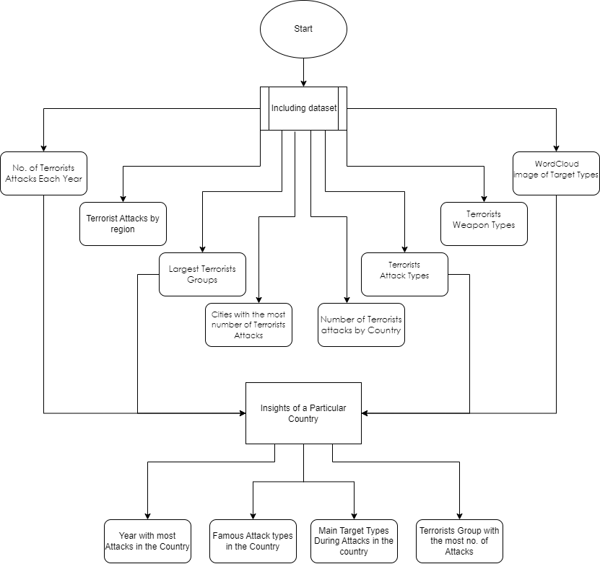

7. References:

* <https://www.youtube.com/>
* <https://www.academicresearchexperts.net/global-terrorism-research-paper/>
* <https://www.kaggle.com/>
* <https://www.google.com/>